PYTHON OOP TASK USING TKINTER

SECTION A

QUESTION 1: OOP using Python (tkinter)

Design a program that will implement the concept of inheritance using the given super class and subclasses.

BELOW IS THE CLASSES:

 | Sick
-MSickID:String
-MDurationOfTreatment:Integer
-MDoctorsID:String

 | TreatmentAmount()
Influenza |  | Cancer
-ConsultationFee:Decimal |  | -ScanFee:Decimal

1.1 | Insert your examination number as a comment in your code.

1.2 | Do the coding for the super class.

1.3 | Do the coding for the Cancer class and take the following information into consideration:  Medication for Cancer is fixed at R400.  Cancer patients pay a Scan Fee.  If the radio button for Cancer is checked, the user enters the Scan Fee in the txtConsultation text box. If the Scan Fee is greater than R600, a message must be displayed Sorry we cannot treat you. If the Scan Fee is less than R600, do the following calculation:  AmountPaidForTreatment = Medication + Scan Fee  AmountPaidForTreatment must be displayed in the label

BELOW IS AN EXAMPLE OF WHAT THE SCREEN SHOTS SHOULD LOOK LIKE (USE THE SAME INFORMATION AS GIVEN BELOW)

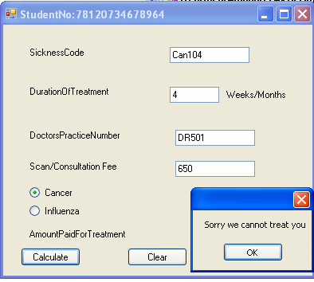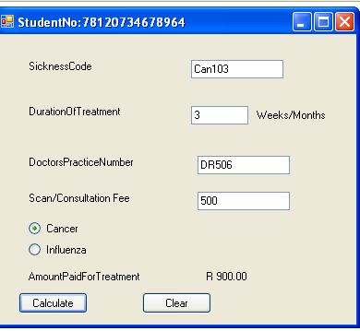
txtConsultation fee ee

1.4 | Do the coding for the Influenza class and take the following information into consideration:  Medication for Influenza is fixed at R350.50.  Influenza patients pay a Consultation Fee.  If the radio button for Influenza is checked, the user enters the Consultation Fee in the txtConsultation text box. If the Consultation Fee is greater than R600, the user gets 2% discount on the Consultation Fee. If the Consultation Fee is less than R600, the user gets No discount.  Do the following calculation:  AmountPaidForTreatment = Medication + Consultation Fee  AmountPaidForTreatment should be displayed in the label.

BELOW IS AN EXAMPLE OF WHAT THE SCREEN SHOTS SHOULD LOOK LIKE (USE THE SAME INFORMATION AS GIVEN BELOW)

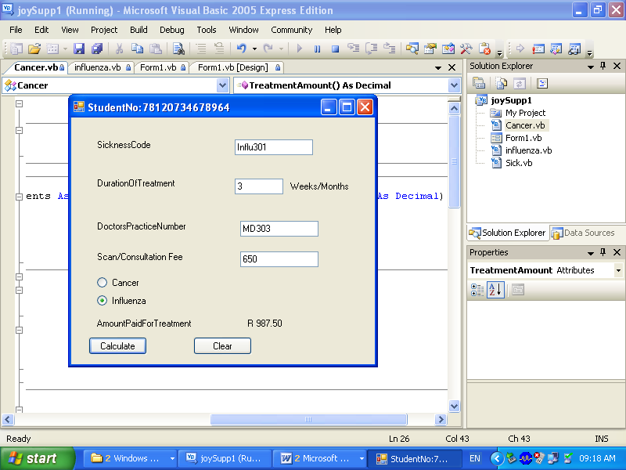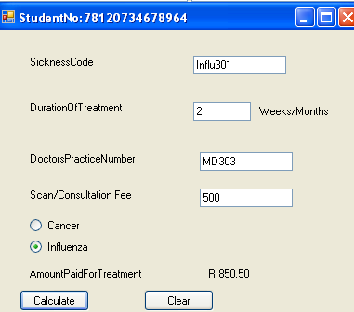
txtConsultation

1.5 | Design the form similar to the above screen shots and code it.

1.6  1.7 | Make a printout of the source code and save it.  Package your program using pyinstaller so that the program is ready for distribution.

